***Advance JavaScript***

***MODULE: 1*** *(Introduction and Code Quality)*

1. **Write a program to Show an alert.**

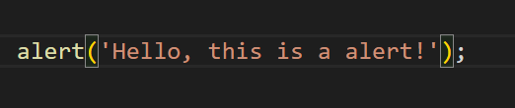

1. **What will be the result for these expressions?**

**1. 5 > 4**

**2. "apple" > "pineapple"**

**3. "2" > "12"**

**4. undefined == null**

**5. undefined === null**

**6. null == "\n0\n"**

**7. 7. null === +"\n0\n"**

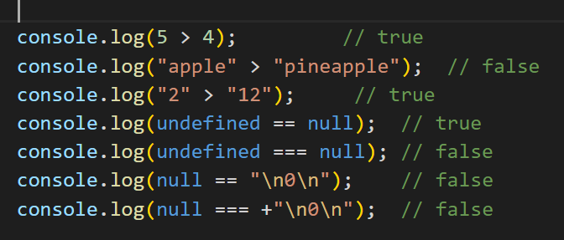

1. **Will alert be shown?**

**if ("0") { alert( 'Hello'); }**

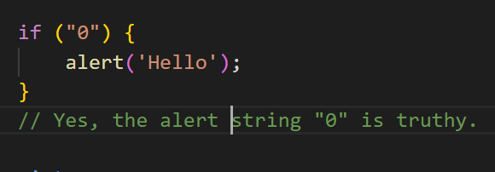

1. **What is the code below going to output?**

**alert( null || 2 || undefined );**

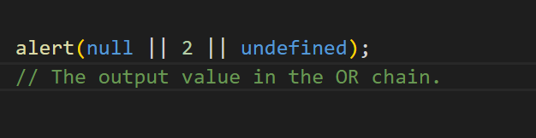

1. **The following function returns true if the parameter age is greater than**

**18Otherwise it asks for a confirmation and returns its result:**

**Function**

**checkAge(age)**

**{**

**else {**

**}**

**}**

**if (age> 18) { return true; }**

**// ...return confirm (‘did parents allow you?');**

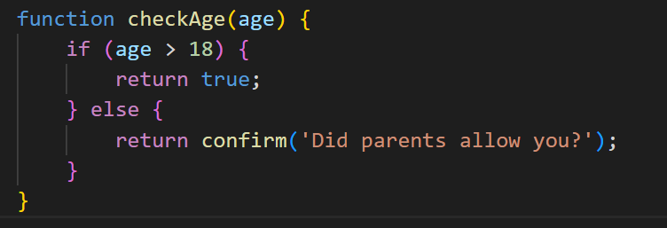

1. **Replace Function Expressions with arrow functions in the code below:**

**Function**

**ask(question, yes, no)**

**{ if (confirm(question))yes();**

**else**

**no();**

**}**

**ask("Do you agree?", function()**

**{ alert("You agreed."); },**

**function() {**

**alert("You canceled the execution."); }**

**}**

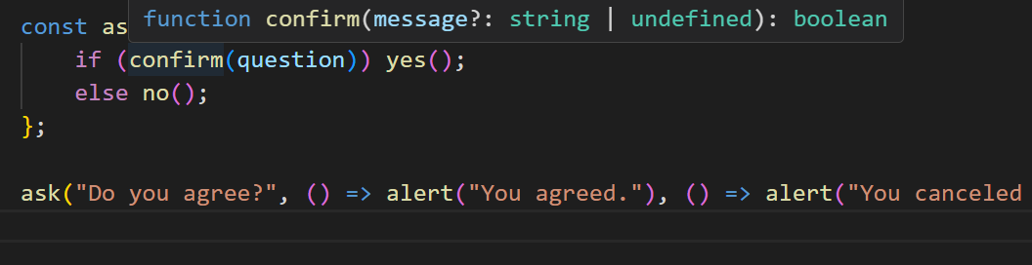

**--------------------*Complete*--------------------------**